Static Culling Transparency

StaticCulling **automatically** knows how to **detect transparent objects** and select the right settings. But it is important to know how to do it yourself.

The objects in this scene were **baked incorrectly**, so the blue cube is **not visible behind** the transparent barrier.

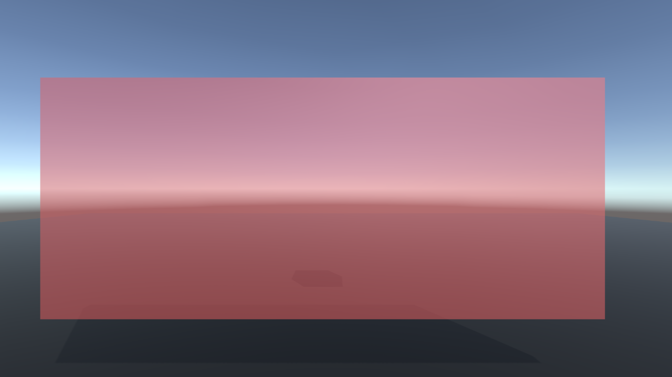

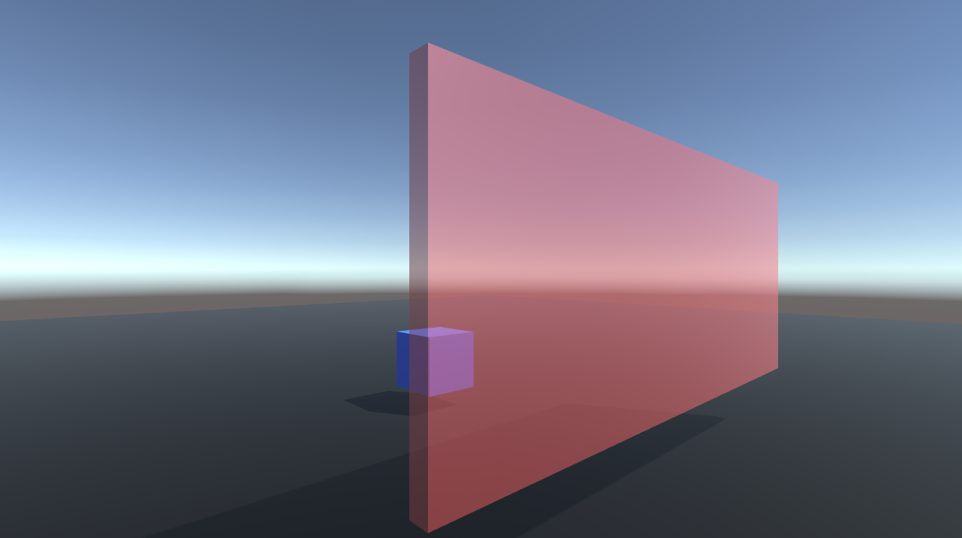

1. To fix this - let's start by **deleting the baked data**. Click “Clear” button in StaticCullingController
2. Add objects using the **Selection Tool**.
3. Add an **existing** CameraZone in Step3
4. Click on the Barrier GameObject and make sure the **isOccluder flag is off.** For **all transparent objects**, this flag should be turned off.

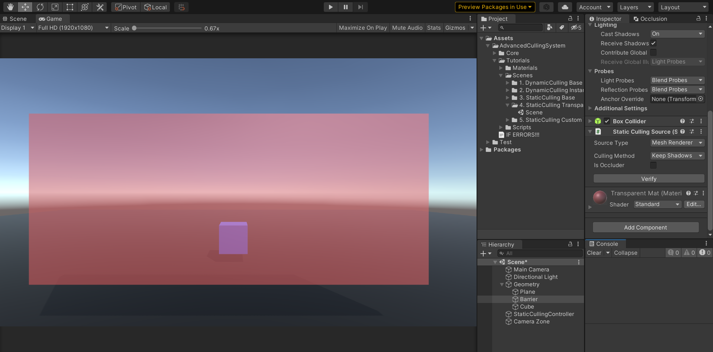

1. Now **bake the scene** and look at the result.